DATA ENGINEERING PROJECT REPORT
ON
“STUDENT ATTENDANCE TRACKING SYSTEM”

Name: Abhinav Singh
Roll Number: 23051398
Batch: Data Engineering
Program: Industry Elective
Department: Computer Science and Engineering

PROBLEM STATEMENT
Traditional attendance systems are often manual, error-prone, and lack real-time tracking capabilities. They do not scale efficiently for large datasets and fail to provide meaningful analytical insights such as attendance trends, defaulter identification, and performance monitoring.
There is a need for an automated system that can capture attendance data in real time, process it efficiently, and generate actionable insights. This project addresses these challenges by developing a real-time attendance tracking system using a streaming data pipeline, ensuring accuracy, scalability, and data-driven decision-making.

SOLUTION & FEATURES
To overcome the limitations of traditional systems, this project proposes an Attendance Tracking System based on real-time data streaming and distributed processing. The system is designed as an end-to-end data pipeline that automates data ingestion, processing, analysis, and visualization.

Solution Overview
The system captures attendance data from CSV input and streams it through a pipeline consisting of Kafka, Spark, and Airflow. The processed data is then analyzed using SQL queries and visualized through dashboards.

Key Features
- Real-Time Data Streaming
- Attendance data is streamed using Apache Kafka
- Enables continuous and real-time data flow
- Automated Workflow Orchestration
- Apache Airflow manages the execution of pipeline tasks
- Ensures proper sequencing (Zookeeper → Kafka → Producer → Spark)
- Scalable Data Processing
- Apache Spark Streaming processes large volumes of data efficiently
- Supports distributed computation
- Structured Data Management
- Data is transformed into a clean and structured format
- Ensures consistency and reliability
- Advanced SQL Analytics
- Multi-level SQL queries (Basic, Intermediate, Advanced)
- Generates insights such as:
- Attendance percentage
- Student ranking
- Defaulter detection
- Course-wise performance
- Visualization Dashboard
- Graphical representation of insights using Python (Matplotlib)
- Includes trends, comparisons, and KPI summaries

System Workflow
The system follows a streaming pipeline architecture:
CSV Data → Kafka Producer → Kafka Topic → Spark Streaming → Processed Data → SQL Analysis → Dashboard
↑
Airflow DAG (Automation)
This workflow ensures smooth data movement from ingestion to visualization.
SCREENSHOTS
- Airflow DAG Execution
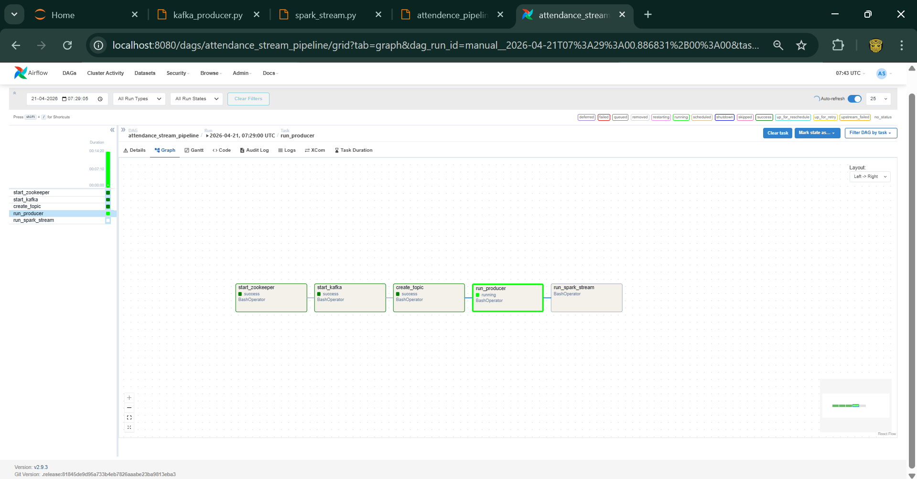
This screenshot shows the successful execution of the Airflow DAG orchestrating the pipeline. All tasks—starting Zookeeper, Kafka, topic creation, producer execution, and Spark streaming—are executed in sequence, indicating correct dependency management and automation.
- Kafka Producer(Streaming Data)
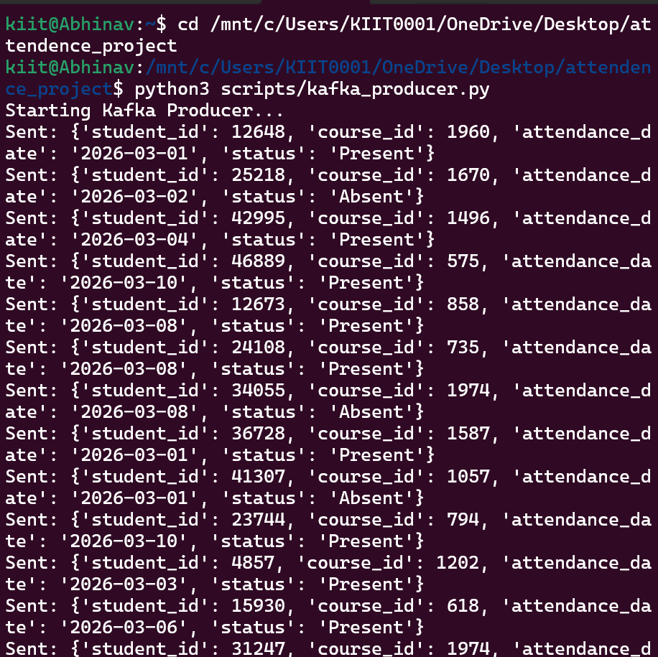
The Kafka producer streams attendance records from a CSV file into a Kafka topic. Each message represents an attendance event (student_id, course_id, date, status), demonstrating real-time data ingestion.
- Spark Streaming Output
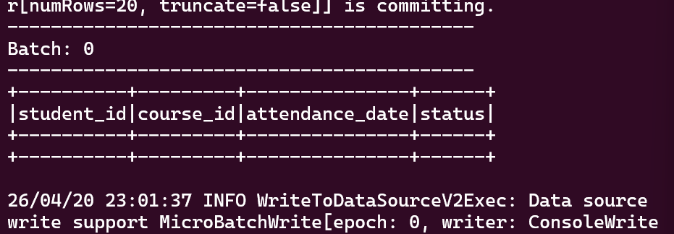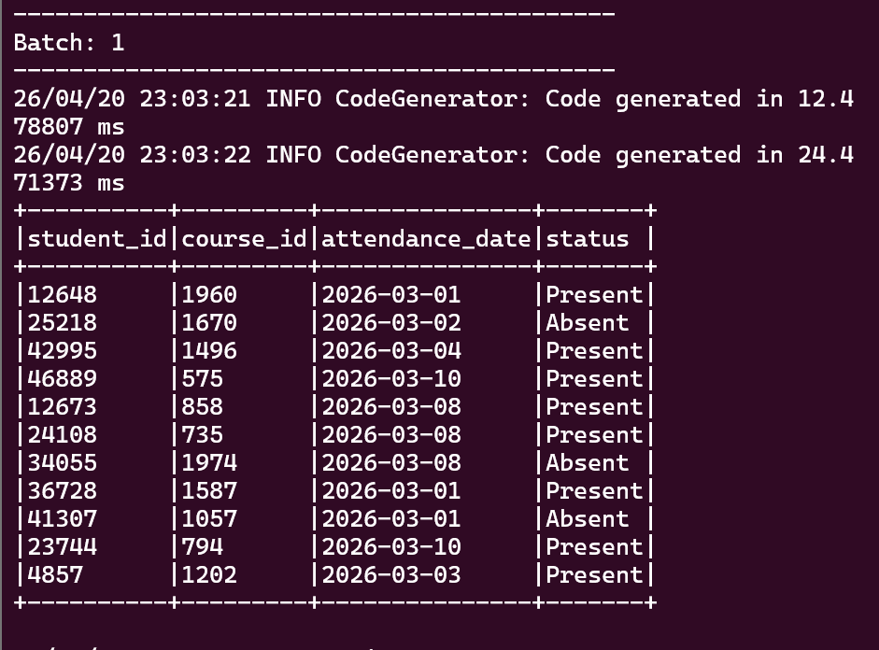
Spark consumes the Kafka stream and processes the data into a structured format. This step performs parsing, basic cleaning, and prepares the dataset for downstream SQL analysis.
- SQL Query Output(Analytics)
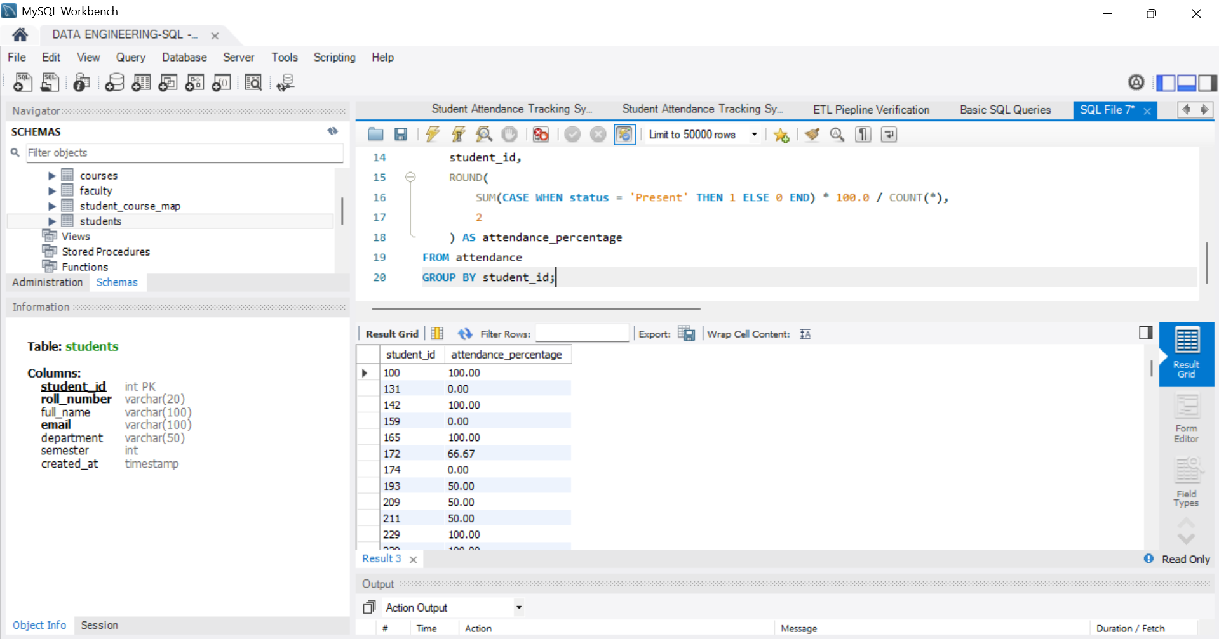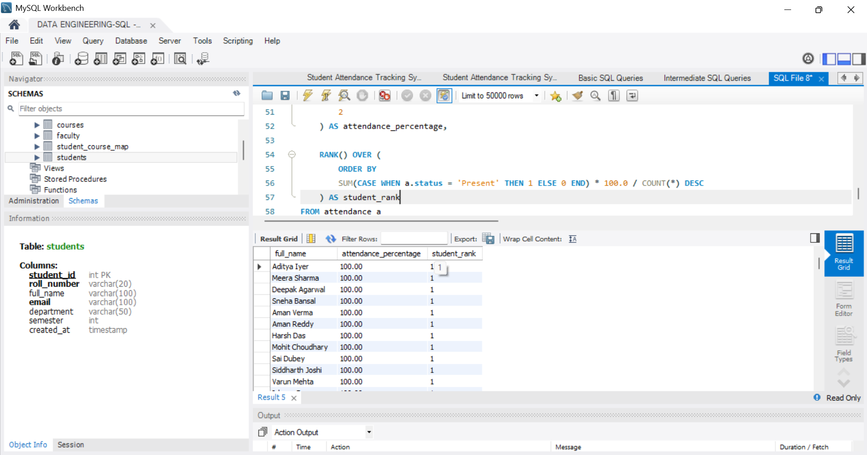
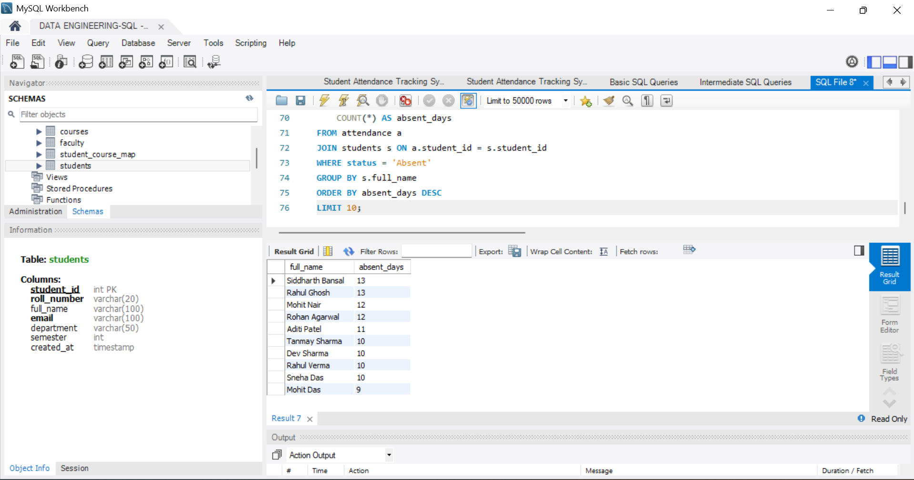
This output demonstrates analytical queries such as attendance percentage calculation, student ranking, and defaulter identification. It validates the correctness of aggregations, joins, and window functions used in the project.
- Attendance Dashboard
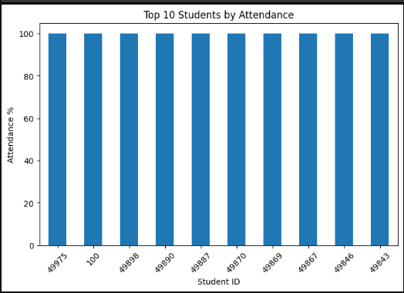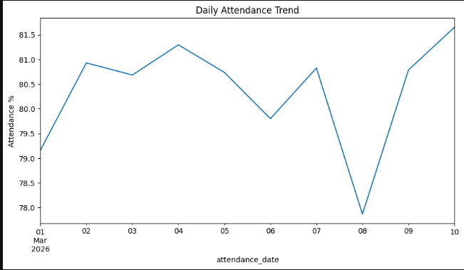
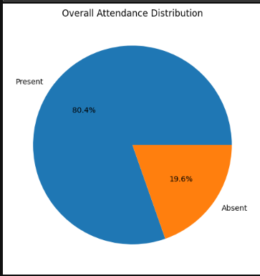
The dashboard visualizes key insights such as top-performing students, overall attendance percentage, and daily attendance trends, enabling clear analysis of student performance and patterns.

TECH STACK
The system is built using modern data engineering tools to enable real-time data processing, automation, and analytics.

Python: Used for Kafka producers, Spark jobs, and visualization.

Apache Kafka: Enables real-time data streaming.

Apache Spark: Processes streaming data efficiently.

Apache Airflow: Automates pipeline execution.

SQL (MySQL): Performs analytical queries.

Matplotlib & Jupyter: Used for visualization.

Git & GitHub: Version control and repository management.

UNIQUE POINTS
This project stands out due to its integration of modern data engineering technologies to build a complete and scalable attendance tracking system.
- End-to-End Data Pipeline:
The system implements a full pipeline from data ingestion to visualization, ensuring seamless flow of data across multiple stages.
- Real-Time Streaming Architecture:
Unlike traditional batch systems, this project uses Apache Kafka and Spark Streaming to process attendance data in real time, enabling instant data availability.
- Workflow Automation using Airflow:
The entire pipeline is automated using Apache Airflow, ensuring proper task scheduling, dependency management, and reduced manual intervention.
- Advanced SQL Analytics:
The project includes multi-level SQL queries, including aggregation, joins, and window functions, to extract meaningful insights such as attendance percentage, ranking, and defaulter identification.
- Insight-Driven Dashboard:
The dashboard focuses on key analytics such as top-performing students, overall attendance, and daily trends, providing a clear understanding of attendance patterns.
- Scalable and Modular Design:
The architecture is designed to handle increasing data volume efficiently and can be extended for real-world deployment scenarios.

FUTURE IMPROVEMENTS
Although the current system successfully implements a real-time attendance tracking pipeline, several enhancements can be made to improve functionality, scalability, and usability.
- Cloud Deployment:
The system can be deployed on cloud platforms such as AWS or Azure to improve scalability, reliability, and accessibility for large-scale usage.
- Real-Time Interactive Dashboard:
Integration with tools like Streamlit or Power BI can enable interactive and live dashboards, allowing users to monitor attendance in real time.
- Machine Learning Integration:
Predictive models can be developed to analyze attendance patterns and forecast student behavior, helping in early identification of potential defaulters.
- Web/Mobile Application Interface:
A user-friendly interface can be developed for students and faculty to mark attendance and view analytics in real time.
- Authentication and Role-Based Access:
Security can be enhanced by implementing login systems and role-based access control for administrators, faculty, and students.
- Database Optimization:
Indexing, partitioning, and query optimization techniques can be applied to improve performance for large datasets.

